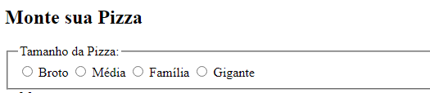

        <section>

            <h2>Monte sua Pizza</h2>

            <form method="POST" action="/pedido">

                <!-- POST  -->

                <fieldset>

                    <legend>Tamanho da Pizza:</legend>

                    <label>

                        <input type="radio" name="tamanho" value="broto">

                        Broto

                    </label>

                    <label>

                        <input type="radio" name="tamanho" value="media">

                        Média

                    </label>

                    <label>

                        <input type="radio" name="tamanho" value="familia">

                        Família

                    </label>

                    <label>

                        <input type="radio" name="tamanho" value="gigante">

                        Gigante

                    </label>

                </fieldset>

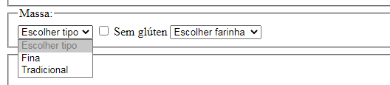

                <fieldset>

                    <legend>Massa:</legend>

                    <select name="massa">

                        <option value="" disabled selected>Escolher tipo</option>

                        <option value="fina">Fina</option>

                        <option value="tradicional">Tradicional</option>

                    </select>

                    <label>

                        <input type="checkbox" name="opt-massa" value="s-gluten">

                        Sem glúten

                    </label>

                    <select name="farinha">

                        <option value="" disabled selected>Escolher farinha</option>

                        <option value="arroz">Farinha de arroz</option>

                        <option value="aveia">Farinha de aveia</option>

                    </select>

                </fieldset>

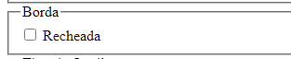

                <fieldset>

                    <legend>Borda</legend>

                    <label>

                        <input type="checkbox" name="borda">

                        Recheada

                    </label>

                </fieldset>

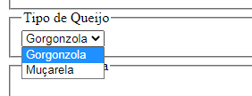

                <fieldset>

                    <legend>Tipo de Queijo</legend>

                    <select name="queijo">

                        <option value="gorgonzola">Gorgonzola</option>

                        <option value="mucarela">Muçarela</option>

                    </select>

                </fieldset>

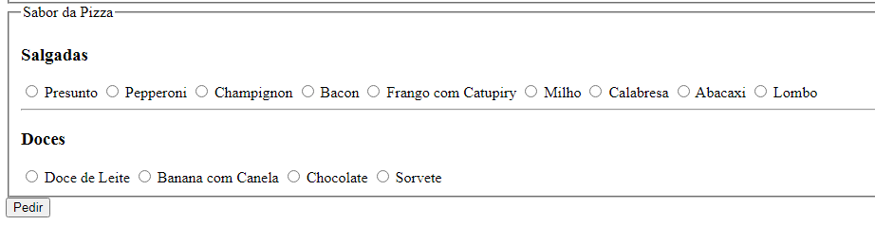

               <fieldset>

                    <legend>Sabor da Pizza</legend>

                    <h3>Salgadas</h3>

                    <label>

                        <input type="radio" name="sabor" value="presunto">

                        Presunto

                    </label>

                    <label>

                        <input type="radio" name="sabor" value="pepperoni">

                        Pepperoni

                    </label>

                    <label>

                        <input type="radio" name="sabor" value="champignon">

                        Champignon

                    </label>

                    <label>

                        <input type="radio" name="sabor" value="bacon">

                        Bacon

                    </label>

                    <label>

                        <input type="radio" name="sabor" value="frango-catupiry">

                        Frango com Catupiry

                    </label>

                    <label>

                        <input type="radio" name="sabor" value="milho">

                        Milho

                    </label>

                    <label>

                        <input type="radio" name="sabor" value="calabresa">

                        Calabresa

                    </label>

                    <label>

                        <input type="radio" name="sabor" value="abacaxi">

                        Abacaxi

                    </label>

                    <label>

                        <input type="radio" name="sabor" value="lombo">

                        Lombo

                    </label>

                    <hr>

                    <h3>Doces</h3>

                    <label>

                        <input type="radio" name="sabor" value="doce-de-leite">

                        Doce de Leite

                    </label>

                    <label>

                        <input type="radio" name="sabor" value="banana-com-canela">

                        Banana com Canela

                    </label>

                    <label>

                        <input type="radio" name="sabor" value="chocolate">

                        Chocolate

                    </label>

                    <label>

                        <input type="radio" name="sabor" value="sorvete">

                        Sorvete

                    </label>

                </fieldset>

                <button type="submit">Pedir</button>

            </form>

        </section>

    </main>

</body>

</html>